Structure of the project:
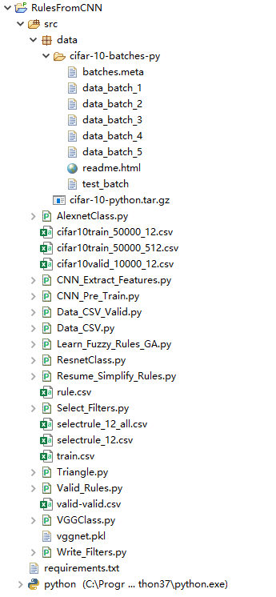

Requirements:
torchvision==0.5.0
torch==1.4.0
numpy==1.18.1
deap==1.3.1
scikit_learn==0.23.1

Step1, train CNN:
Model definition: VGGClass.py, AlexnetClass.py, ResnetClass.py
Source file: CNN_Pre_Train.py
Input: image classification data
Output: pre_trained models, such as “vggnet.pkl”
Description: train model for 100 epochs with learning_rate=0.1, 0.01,0.001, respectively

Step2, extract features from CNN:
Source file: CNN_Extract_Features.py
Input: pre_trained models, such as “vggnet.pkl”
Output: feature data files, such as “cifar10train_50000_512.csv”,
(for the limit of file size, the file only contains 500
examples)
Description: for batch_idx, (inputs, targets) in enumerate(trainloader): #change trainloader to testloader for extracting features from validate set

Step3, select filters
Source file: Select_Filters.py
Input: feature data files, such as “cifar10train_50000_512.csv”
Output: array of selected filters, such as:
“s= [0, 1, 22, 96, 110, 191, 231, 239, 242, 267, 317, 384, 398, 435]”
Description: turn parameters activatoinsValue and activatoinsCount for obtaining appropriate filters

Step4, write activations of filters to file
Source file: Write_Filters.py
Input: feature data files, such as “cifar10train_50000_512.csv”
array of selected filters, such as:
“s= [0, 1, 22, 96, 110, 191, 231, 239, 242, 267, 317, 384, 398, 435]”
Output: activations files, such as: “cifar10train_50000_12.csv”
Description: none

Step5, learn fuzzy rules from activations
Source file: Triangle.py, Data_CSV.py, Learn_Fuzzy_Rules_GA.py
Input: activations train files, such as: “cifar10train_50000_12.csv”
Output: the accuracy of each generation, “train.csv”
the rules of each generation, “rule.csv”
Description: none

Step6, validate fuzzy rules
Source file: Data_CSV_Valid.py, Valid_Rules.py
Input: activations files of validate set,
such as: “cifar10valid_10000_12.csv”
selected fuzzy rules file:
such as: “selectrule_12.csv”
Output: the accuracy of validate set
Description: none

Step7, simplify fuzzy rules
Source file: Resume_Simplify_Rules.py
Input: activations train files,
such as: “cifar10train_50000_12.csv”
selected fuzzy rules files:
such as: “selectrule_12.csv”
Output: the accuracy, rulecount, correctcount of train set
Description: turn ElistPoolSize, fitness function to obtained different trade-offs

